

# JENKINS CI AND CD PIEPLINE

**AGENDA**

* **CONTINUOUS INTEGRATION AND CONTINUOUS DELIVERY.**
* **JENKINS PIPELINE.**
* **HOW MANY WAYS WE CAN CREATE PIPELINE?**
* **CREATE JENKINS PIPELINE USING GROOVY SCRIPT / JENKINS FILE.**

**CONTINUOUS INTEGRATION AND CONTINUOUS DELIVERY:**

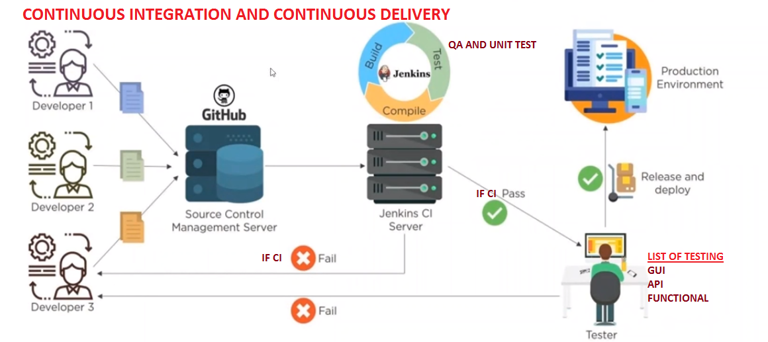

**JENKINS PIPELINE:**

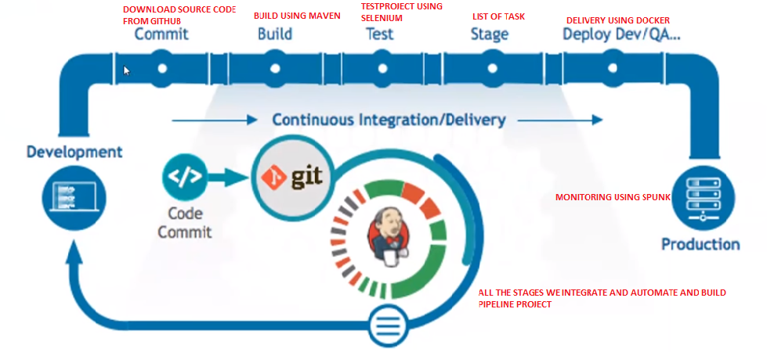



**HOW MANY WAYS WE CAN CREATE A PIPELINE?**

1. **USING BUILD AND DELIVERY PIPELINE PLUG-INS**
2. **USING GROOVY SCRIPT ON THE FLY(HERE WE USE JENKINS FILE)**
3. **SCRIPTED PIPELINE**
4. **DECLARATIVE PIPELINE**

**DIFFERENCE BETWEEN PLUG-IN AND GROOVY PIPELINE**

|  |  |
| --- | --- |
| **PLUG-IN PIPELINE** | **GROOVY PIPELINE** |
| Difficult to link and automate multiple sub-jobs | Easy to Link and Automate Multiple staged sub-jobs whenever we need |
| Portable for simple - Project | Portable for any type of - Projects |
| In Single pipeline we can integrate all jobs sequentially and run | With one single pipeline we can automate all stages through groovy script |
|  |  |

**CREATE JENKINS PIPELINE USING GROOVY SCRIPT / JENKINS FILE**

**SCRIPTED PIPELINE:**

**CREATE AN NEW ITEM:**

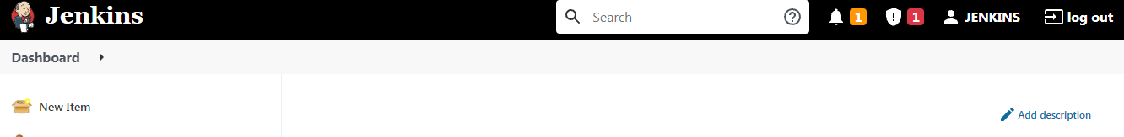

**NAME THE JOB: Jenkins-Scriptedpipeline**

**SELECT THE CONFIGURATION: Pipeline**

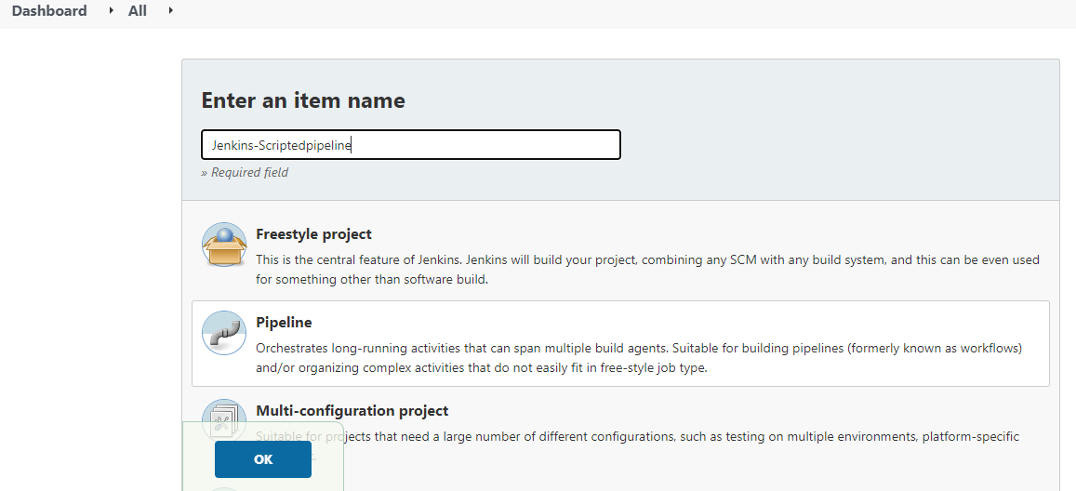



**Under pipeline we have Scripted and Declarative Pipelines are there,**

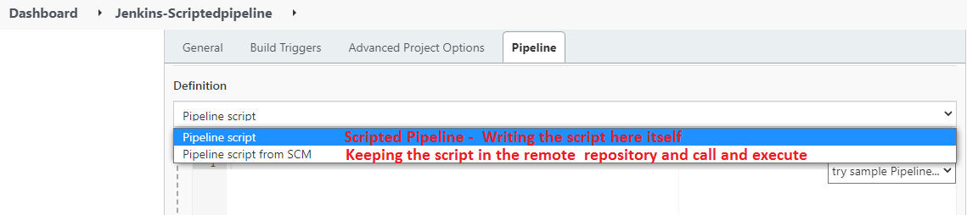

**UNDER PIPELINE WRITE GROOVY SCRIPT**

**SAMPLE CODE WITHOUT ANY COMMAND WE USED SIMPLE SCRIPT TO TEST A PIPELINE: APPLY AND SAVE**

**node**

**{**

**stage('Commit')**

**{**

**echo "This is Code Download from GIT Project Repository.................."**

**}**

**stage('Build')**

**{**

**echo "This is Build project using maven.................."**

**}**

**stage('Test')**

**{**

**echo "This is Test project Implementation using Selenium................."**

**}**

**stage('Release')**

**{**

**echo "This is Delivery using Docker......................................"**

**}**

**stage('Monitor')**

**{**

**echo "This is Application Logs Monitorinig using tool Splunk............."**

**}**

**}**

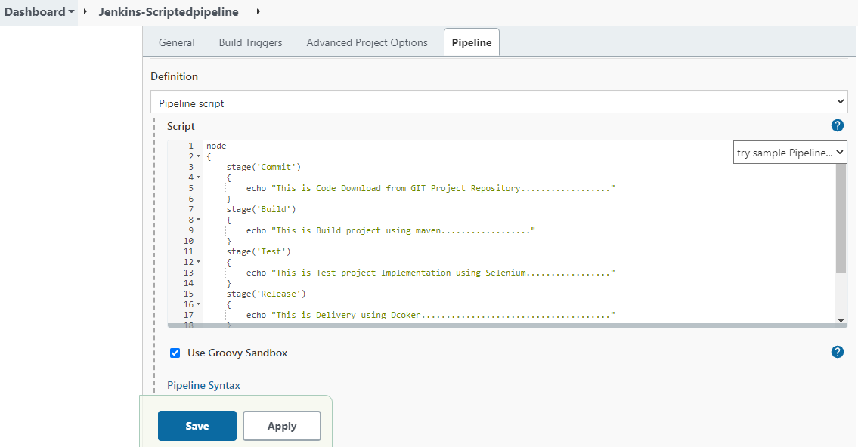



**Under pipeline we have Scripted and Declarative Pipelines are there,**

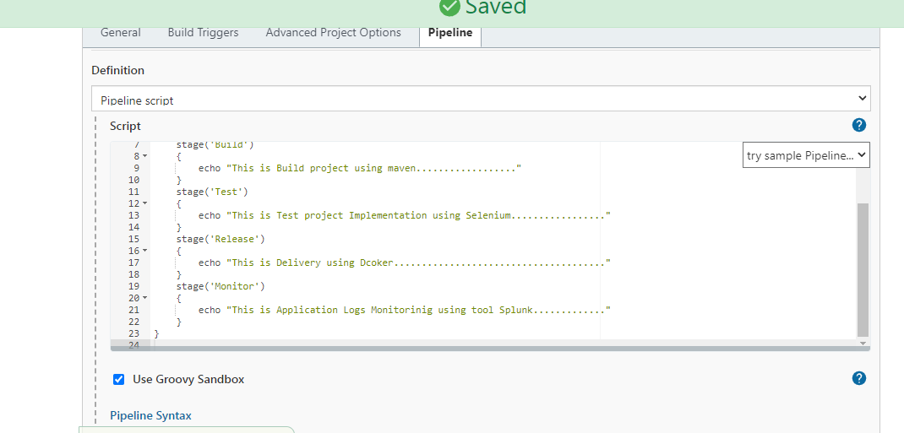

**CLICK ON BUILD NOW & VERIFY THE LOGS:**

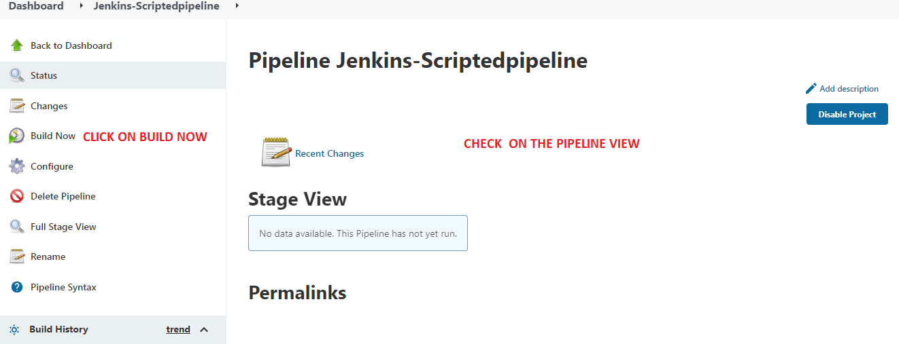

**CHECK THE BUILD AND SEE THE VIEW CREATED:**

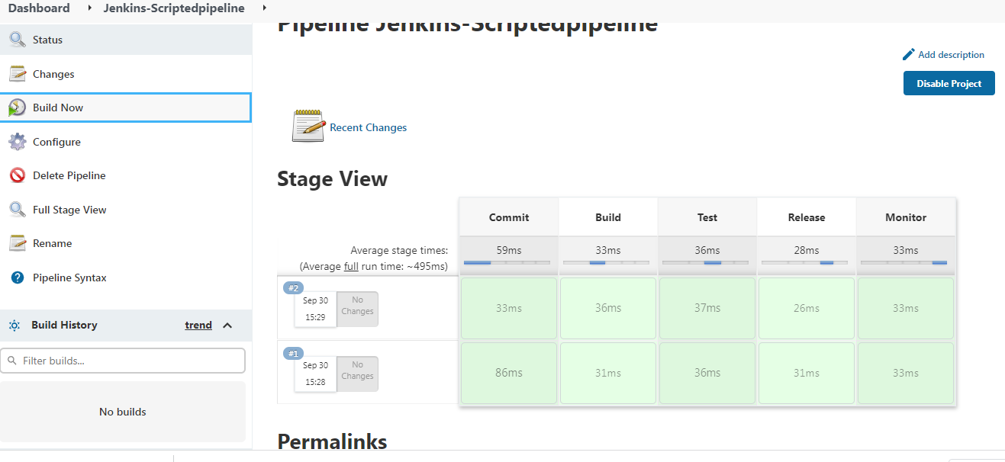



**DECLARATIVE PIPELINE:**

**Jenkinsfile.txt we keep in some remote repository and jenkins would auto-trigger the same and do project run as per the script written.**

**Create jenkinsfile.txt**

**Commit jenkinsfile.txt into GITHUB**

**Integrate GITHUB and JENKINS Using GITHUB plug-in**

**Then set-up to run the Declarative pipeline**

**Sample source code:**



**This may need git knowledge hence showing only the demo that how to do it….**